A Project Report on

**Doctor Appointment Booking System**

Submitted

In Partial Fulfillment of the Requirements

For the Degree Of

Bachelor of Science

[Computer Applications & Information Technology]-VI

**Submitted to**



**Department of Computer Science,**

**HEMCHANDRACHARYA**

**NORTH GUJRAT UNIVERSITY**

**Submitted By: Project Guide:**

Basan Nofal[147] Hinal Prajapati

Aghariya Arman[36] Tushar Parikh

Sunasara Sajjad[177]

**ACKNOWLEGGEMENT**

With immense pleasure, we present this report on the project assignment titled “Health-Center”.

We are lifelong indebted towards **B.M.Patel** Director of DCS H.N.G. University, Patan for Providing us environment that is best suited for outgrowth of the student’s personality and bring up there moral and constant encourage and guidance helped us in completing this project

We are also lifelong indebted to the professor **Mrs. Hinal Prajapati** for provide us with inspiration, knowledge and all kinds of support throughout 6th semester of M.Sc. (CA & IT) studies. We from the fathoms of our heart, thank all the members of DCS H.N.G. University for their invaluable technical and moral support.

The encouragement and help received from our parents, family members, friends and colleagues cannot be. expressed in terms of words. Without this moral support, the work would have been lift unfinished

|  |  |  |
| --- | --- | --- |
| **Sr. No** | **Table of Content** | Page No. |
| **1.** | **Introduction**   * 1. Project Profile   2. Project Definition | **1**  **2**  **3** |
| **2.** | **System Analysis**   * 1. Hardware &Software Configuration   2. Requirement Analysis   3. Existing System   4. Need for new system   5. System Modules | **4**  **3**  **6**  **7**  **8** |
| **3.** | **System Design**  3.1 DFD Diagram  3.2 Data Dictionary  3.3 ER-Diagram | **10**  **11**  **15**  **20** |
| **4.** | **Interface Design**  4.1 Screenshots  4.1.1 User Module  4.1.2 Doctor Module  4.1.3 Admin Module | **21** |
| **5.** | **Conclusion & Future work** | **38** |
| **6.** | **References & Bibliography** | **39** |

**1. INTRODUCTION**

* 1. **Project Profile**

|  |  |
| --- | --- |
| PROJECT TITLE | Health-Center |
| DEVELOPED BY | Basan Nofal  Aghariya Arman  Sunasara Sajjad |
| FRONT END TOOLS | HTML ,CSS ,JavaScript , Bootstrap 4, Eclipse IDE |
| BACK END TOOLS | JSP, Servlet |
| Database END TOOLS | MySQL |
| DOCUMENTATION TOOL | Microsoft Word, Microsoft PowerPoint, Canva |
| PROJECT DURATION | 50 Days |
| TEAM MEMBER | 3(Three) |
| SUBMITTED TO | DCS, HNG Univercity, Patan |
| INTERNAL GUIDE | Mrs. Hinal Prajapati  Mr.Tushar Parikh |

* 1. **Project Definition**

An online doctor appointment booking system. The main goal of this project was to create a easy appointment booking system for patients so that they can book an appointment from anywhere whichallows patients to search for doctors and book an appointment online Moreover, the project is also designed in such a way it lets receptionist manage the appointments, feedbacks, users as well as doctors information.

In today's busy world it becomes very tough to book an appointment by being physically present at the hospital. Using our website anyone can book appointment by sitting in a room with the help of Internet.

The application is implemented in JAVA and consists of three main components:

* Admin Side
* Patient Side
* Doctor side

Admin side consists of the features such as Creating Username & Password, Add and Remove Doctors, Add and Remove patient, and Logout.

Patient side consists of the features such as Registration Login, Search Doctor, Book an Appointment, Give Feedback,Update Profile, And Logout.

Doctor side consists of the features such as Registration,Login, View Appointment, Confirm Appointment, FeedbackUpdate Profile, And logout

**2. SYSTEM ANALYSIS**

**2.1 Hardware & Software Configuration**

The hardware requirements are:

* Processor: Pentium IV Processor
* Hard Disk: 80 GB HDD
* Ram: 512 MB and above

The Software specification are:

* Operating System: Window 7 and above
* HTML, CSS, Bootstrap,JavaScript (Front End)
* MYSQL (Back end)
* JSP,Servlet (Server-side programming)
* Wamp Server

**2.2 Requirement Analysis**

The first step in developing the system is analysing the problem. Before developing a system, the problem should be well defined Identifying the need for a new information system and launching an investigation and a feasible study must be done to check whether the software is visible for the organization. This unit we have done this study.

Lack of security is another problem of the existing system. That may lead to serious problems. It will affect the business career. In the existing system, there is no facility for the user to see the data. The existing system is not reliable because of human errors.

Because of the above reasons the existing system need to be change, for the easy and smooth running of the system.

**2.3 Existing System**

In this section we shall discuss the limitation and drawback of the existing system thatforced us to take up this project. Really that work was very typical to manage the dailyerrors free records and adding or removing any node from server.This problem produces a need to change the existing system.Some of these shortcomings are being discussed below:

* The existing system of doctor appointment is to manage the relationshipwith User members by storing the user data in registers.The existing system has following drawbacks:
* Manual working system is there,so many problems occurred like
* Error during entry process.Lots of the time consumed for each report generation.
* Wrong request can be done so fake transaction may be possible.
* They don't have centralized database to maintain information.
* Retrieving of records is difficult.
* Complexity in working process, thus time consuming.
* Maintenance of patient record is very difficult.
* Reports are not viewed by the users in proper and systematic way.
* Costly.

**2.4 Need for new system**

The proposed system ofDoctor Appointment can also be known as Nongovernmental Organization website, because we will use the new technology formanaging the relationship with user’s, like as web technology.

We proposed complete website solution for the application to create "User Relationship Management"website.Theiterative,time bound approach adopted by theorganization to address the client requirements that are as follows:

* Fully Automated System is used.
* Centralized database with no redundancy i.e. proper normalization.
* Common platform for patients and doctors.
* Both parties will be benefited.
* Any time anywhere facility.
* User friendliness.
* Secured.

**2.5 System Modules**

**MODULE DESIGN**

There are main three module

1. Admin
2. Patient
3. Doctor
4. **Admin:**

* Doctor Management
* Patient Management
* Validate Doctor
* View all appointments
* View Feedback
* Generate Report

1. **Patient:**
   * + - * Registration
         * Login
         * Search Doctor
         * Give Feedback
         * Book an Appointment
         * Manage Profile
2. **Doctor:**

* Registration
* Login
* View Schedule
* Appointment Manage
* Manage Profile
* Patient Report
* View Feedback

**Economic Feasibility**

This is a very important aspect to be considered while developing a project. We decided the technology based on minimum possible cost factor.

• All hardware and software cost has to be borne by the organization.

• Overall we have estimated that the benefits the organization is going to receive from the proposed system will surely overcome the initial costs and the later on running cost for system.

**Technical Feasibility**

This included the study of function, performance and constraints that may affect the ability to achieve an acceptable system. For this feasibility study, we studied complete functionality to be provided in the system, as described in the System Requirement Specification (SRS), and checked if everything was possible using different type of frontend and backend platforms.

**Operational Feasibility**

No doubt the proposed system is fully GUI based that is very user friendly and all inputs to be taken all self-explanatory even to a layman. Besides, a proper training has been conducted to let know the essence of the system to the users so that they feel comfortable with new system. As far our study is concerned the clients are comfortable and happy as the system has cut down their loads and doing.

**3. SYSTEM DESIGN**

**3.1 Data Flow Diagram (DFD)**

* **DFD Level 0**

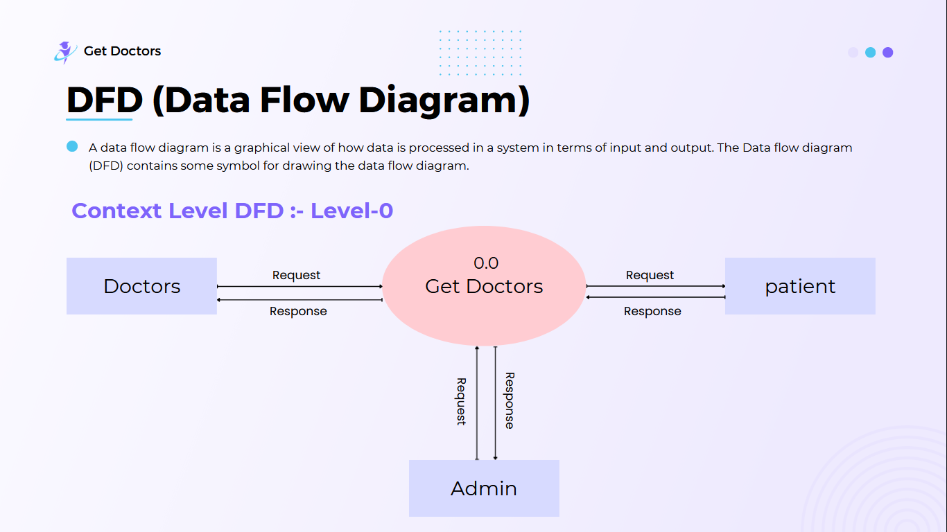

* **DFD Level 1**

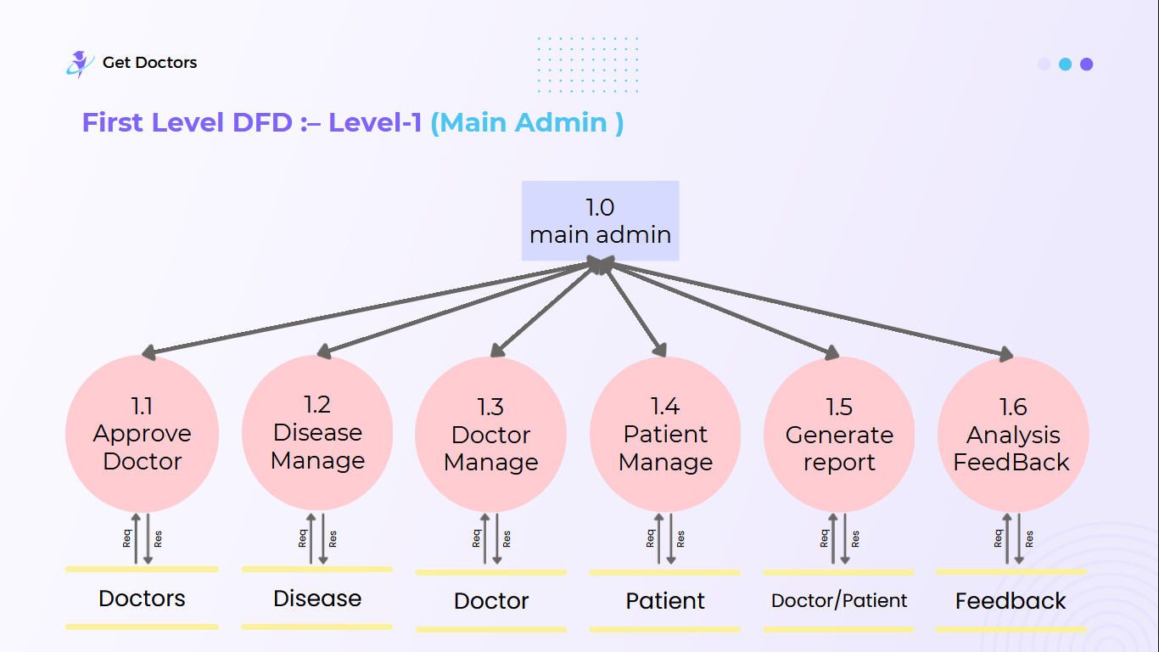

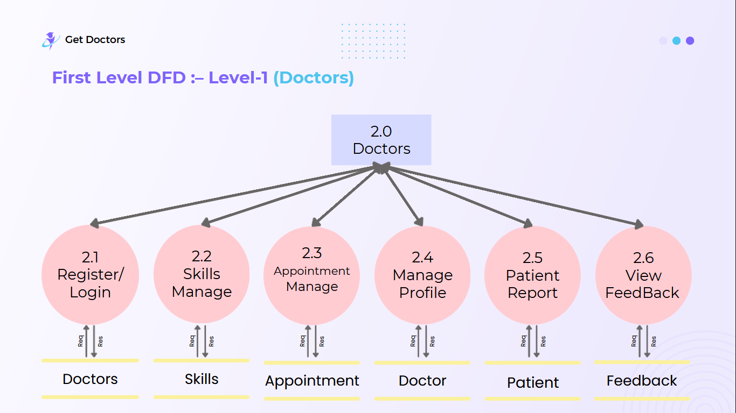

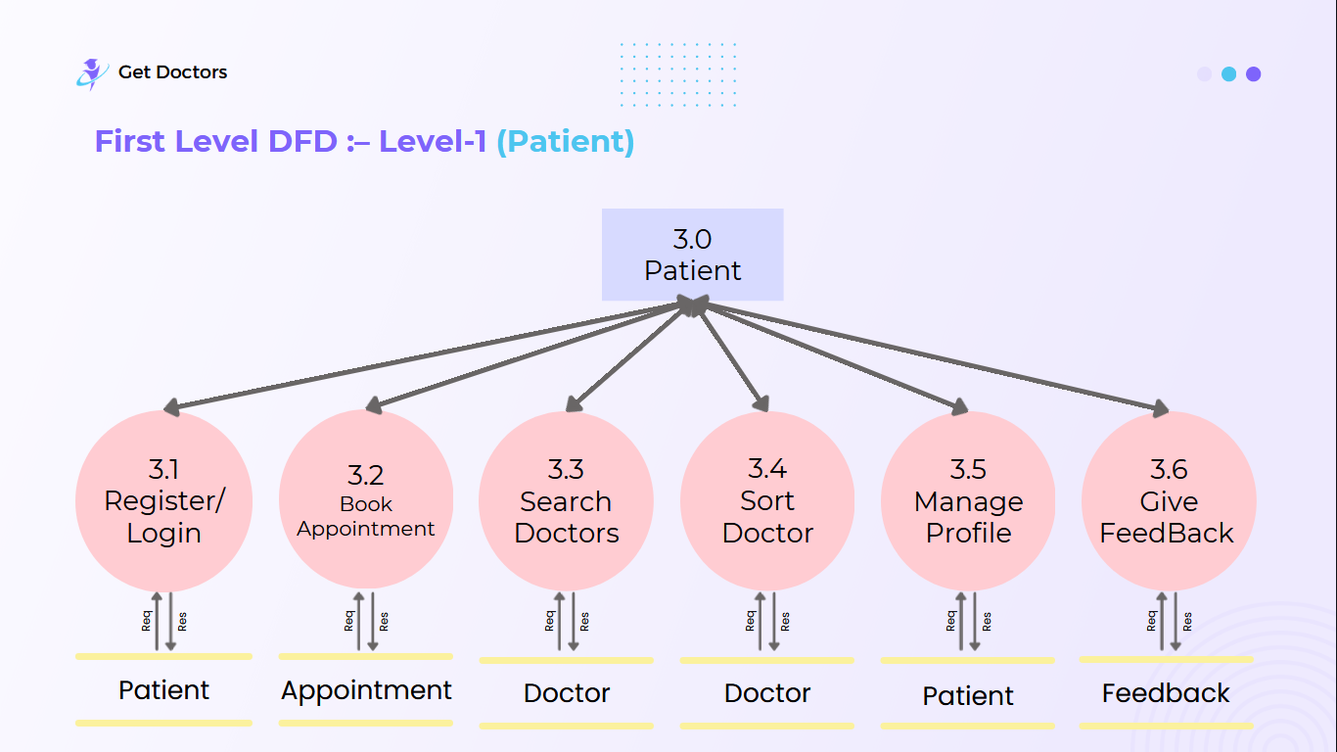

* **DFD Level 2**

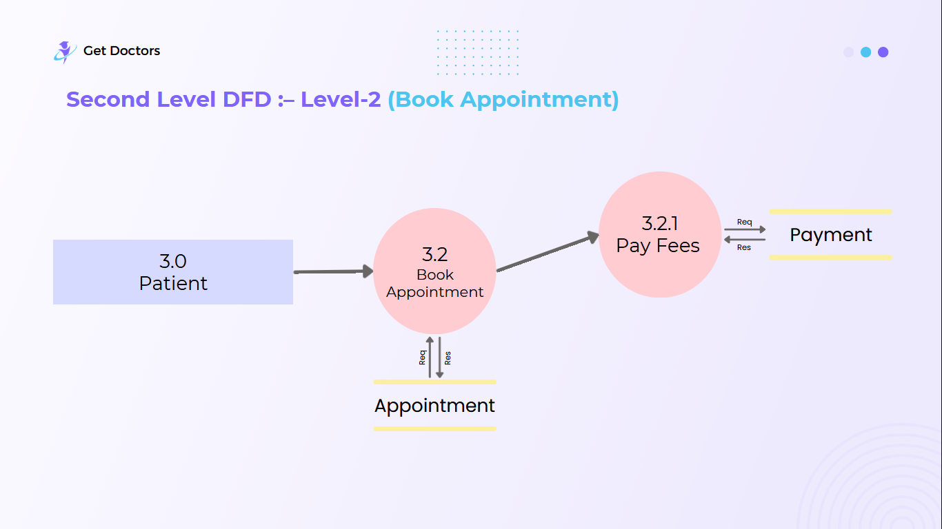

Working Flow

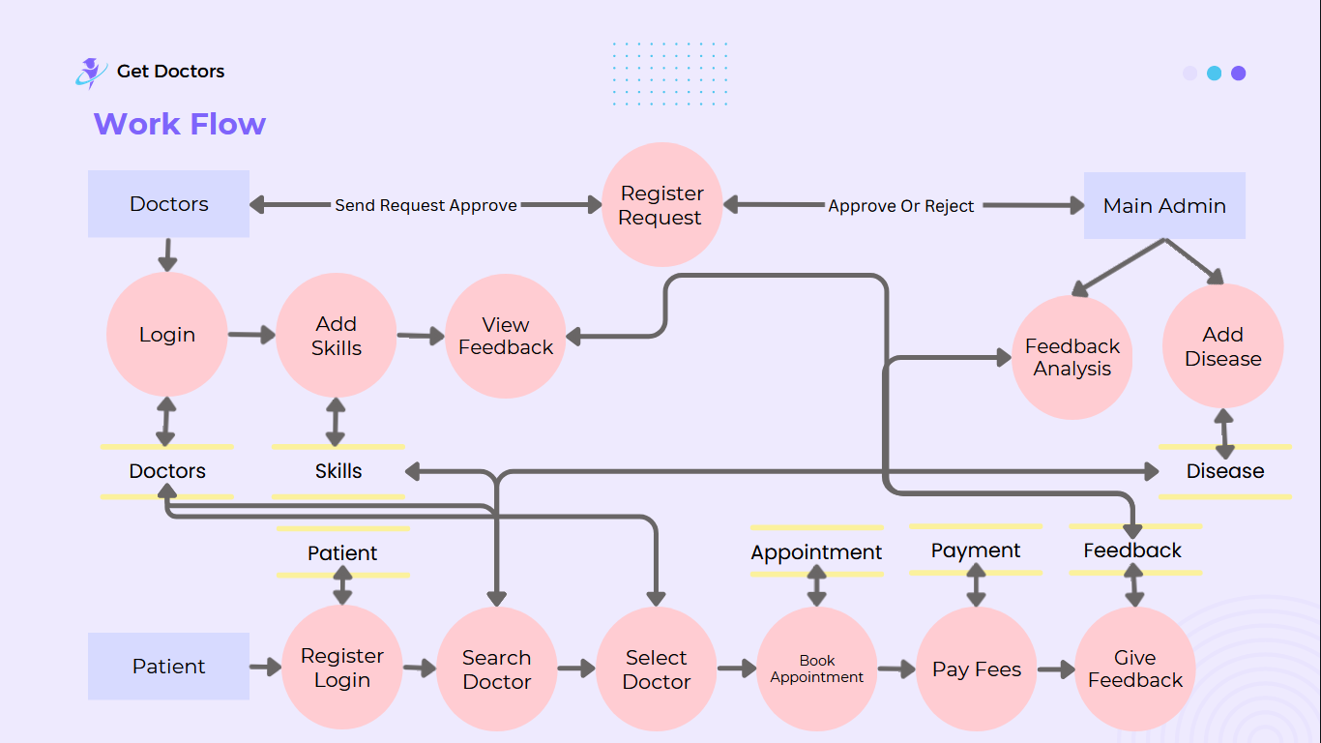

**3.2 Data Dictionary**

**Table Name: -** main_admin

**Description: -**To store admin credentials.

**Primary Key:** - id

|  |  |  |  |  |  |
| --- | --- | --- | --- | --- | --- |
| **SR.NO.** | **FIELD** | **TYPE** | **SIZE** | **CONSTRAINTS** | **DESCRIPTION** |
| 1 | admin_id | int | 20 | Primary Key | Admin ID |
| 2 | username | Varchar | 50 | Not null | Admin Username |
| 3 | email | Varchar | 50 | Not null | Admin email |
| 4 | password | Varchar | 50 | Not null | Admin password |
| 5 | number | varchar | 20 | Not null | Admin number |

**Table Name: -** patient

**Description: -** To store the user details.

**Primary Key:** - patient_id

|  |  |  |  |  |  |
| --- | --- | --- | --- | --- | --- |
| **SR.NO.** | **FIELD** | **TYPE** | **SIZE** | **CONSTRAINTS** | **DESCRIPTION** |
| 1 | Patient_id | int | 20 | Primary Key | User unique Id |
| 2 | name | Varchar | 50 | Not Null | Patient name |
| 3 | email | Varchar | 50 | Not null | Patient Mobile no. |
| 4 | address | Varchar | 50 | Not null | Patient address |
| 5 | age | int | 20 | Not Null | Patient age |
| 6 | number | varchar | 20 | Not null | Patient number |
| 7 | username | Varchar | 50 | Not Null | Patient username |
| 8 | password | Varchar | 50 | Not Null | Patient password |

**Table Name: -** doctor

**Description: -**To store Doctor details.

**Primary Key:** - Doctor_id

|  |  |  |  |  |  |
| --- | --- | --- | --- | --- | --- |
| **SR.NO.** | **FIELD** | **TYPE** | **SIZE** | **CONSTRAINTS** | **DESCRIPTION** |
| 1 | doctor_id | int | 20 | Primary Key | Doctor ID |
| 2 | name | Varchar | 50 | Not Null | Doctor Name |
| 3 | number | varchar | 20 | Not null | Phone No |
| 4 | email | Varchar | 50 | Not null | E-mail ID |
| 5 | password | Varchar | 50 | Not null | Password |
| 6 | address | Varchar | 50 | Not null | Address |
| 7 | specialization | Varchar | 50 | Not null | Specialization |
| 8 | qualification | Varchar | 50 | Not null | Qualification |
| 9 | Profile_picture | Varchar | 50 | Not null | Profile Picture |
| 10 | status | Varchar | 50 | Not null | status |
| 11 | username | Varchar | 50 | Not null | username |

**Table Name: -** Appointment

**Description: -**This table is used for store appointment details

**Primary Key:** - appointment_id

|  |  |  |  |  |  |
| --- | --- | --- | --- | --- | --- |
| **SR.NO.** | **FIELD** | **TYPE** | **SIZE** | **CONSTRAINTS** | **DESCRIPTION** |
| 1 | appointment_id | int | 20 | Primary Key | Appointment ID |
| 2 | patient_name | Varchar | 50 | Not null | patient Name |
| 3 | patient_email | Varchar | 50 | Not null | Patient email |
| 4 | appointment_date | Varchar | 50 | Not null | Appointment date |
| 5 | appointment_time | Varchar | 50 | Not null | Appointment time |
| 6 | additional_note | Varchar | 50 | Not null | Description |
| 7 | doctor_id | Varchar | 50 | Foreign key | Doctor id |
| 8 | patient_id | int | 20 | Foreign key | Patient id |
| 9 | disease | int | 50 | Foreign key | Description |

**Table Name: -** feedback

**Description: -**To store feedbacks.

|  |  |  |  |  |  |
| --- | --- | --- | --- | --- | --- |
| **SR.NO.** | **FIELD** | **TYPE** | **SIZE** | **CONSTRAINTS** | **DESCRIPTION** |
| 1 | review_id | int | 20 | Primary Key | Review Id |
| 2 | rating | int | 20 | Not null | Rating |
| 3 | review_text | Varchar | 50 | Not null | Description |
| 4 | review_date_  time | DateTime |  | Not null | Date&Time |
| 5 | doctor_id | int | 20 | Foreign key | Doctor id |
| 6 | patient_id | int | 20 | Foreign key | Patient id |

**Table Name: -** Skill

**Description: -**To store skill.

|  |  |  |  |  |  |
| --- | --- | --- | --- | --- | --- |
| **SR.NO.** | **FIELD** | **TYPE** | **SIZE** | **CONSTRAINTS** | **DESCRIPTION** |
| 1 | skill_id | int | 20 | Primary Key | Review Id |
| 2 | Skill_name | Varchar | 50 | Not null | Skill name |
| 3 | status | Varchar | 50 | Not null | status |
| 4 | doctor_id | int | 20 | Foreign key | Doctor id |

**Table Name: -** Disease

**Description: -**To store Disease.

|  |  |  |  |  |  |
| --- | --- | --- | --- | --- | --- |
| **SR.NO.** | **FIELD** | **TYPE** | **SIZE** | **CONSTRAINTS** | **DESCRIPTION** |
| 1 | disease_id | int | 20 | Primary Key | disease Id |
| 2 | disease_name | Varchar | 50 | Not null | disease name |
| 3 | status | Varchar | 50 | Not null | status |

**Table Name: -** payment

**Description: -**To store Disease.

|  |  |  |  |  |  |
| --- | --- | --- | --- | --- | --- |
| **SR.NO.** | **FIELD** | **TYPE** | **SIZE** | **CONSTRAINTS** | **DESCRIPTION** |
| 1 | payment_id | int | 20 | Primary Key | payment Id |
| 2 | payment_amount | Int | 50 | Not null | Payment amount |
| 3 | payment_date_time | dateTime |  | Not null | Date and time |
| 4 | payment_status | Varchar | 50 | Not null | Status |
| 5 | doctor_id | Int | 10 | Foreign key | Doctor id |
| 6 | patient_id | Int | 10 | Foreign key | Patient id |

**3.3 Entity Relationship**

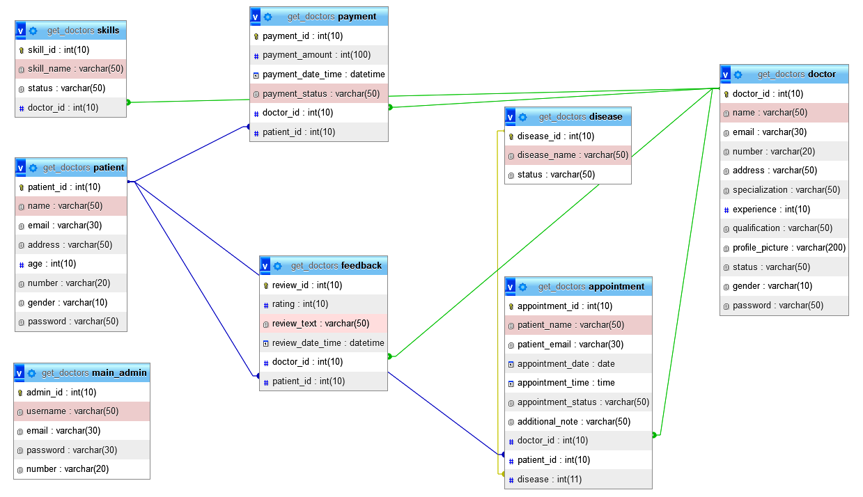

**4. Interface Design**

**4.1 Screenshots**

**4.1.1 User Module**

**Index/Home page (before login)**

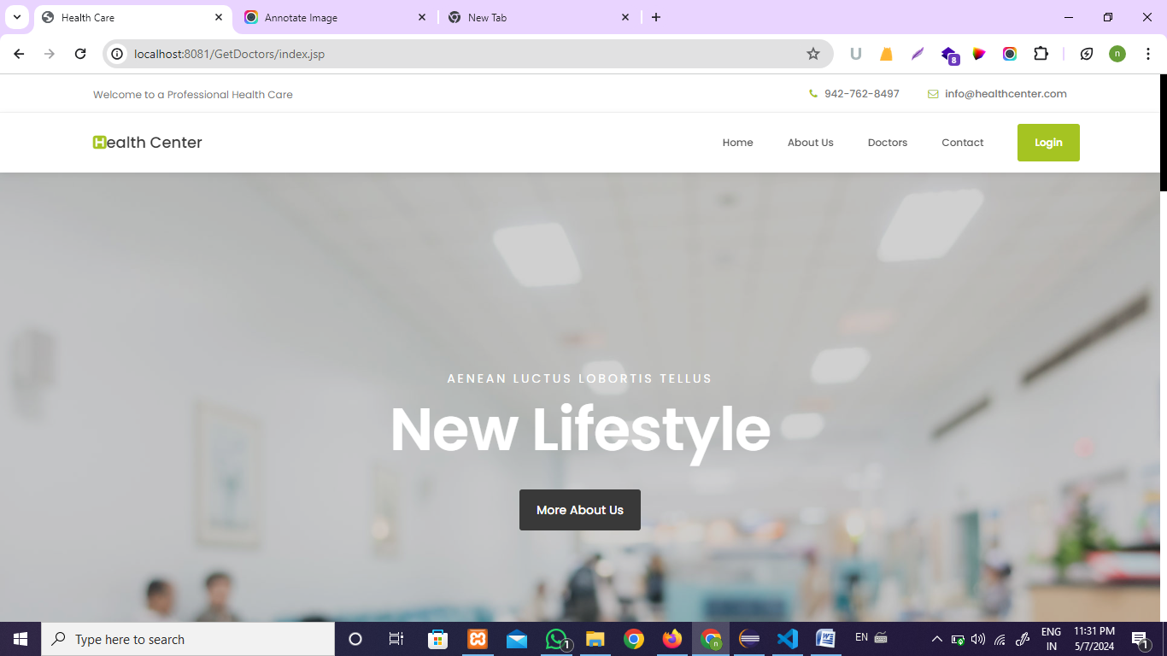

**Home page (After Login)**

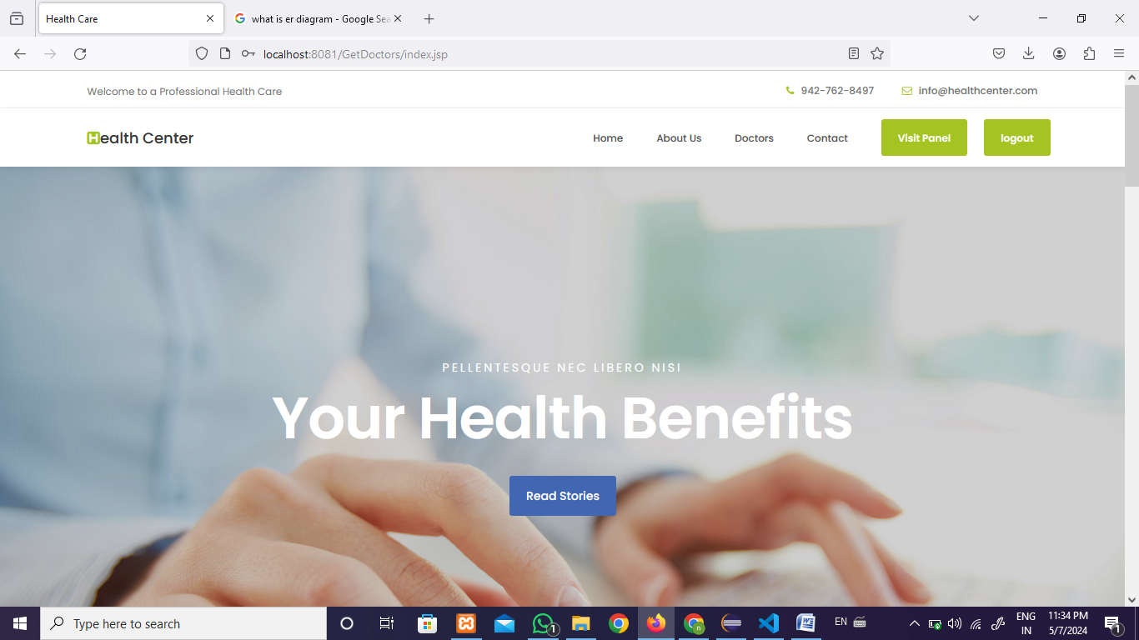

**About Page**

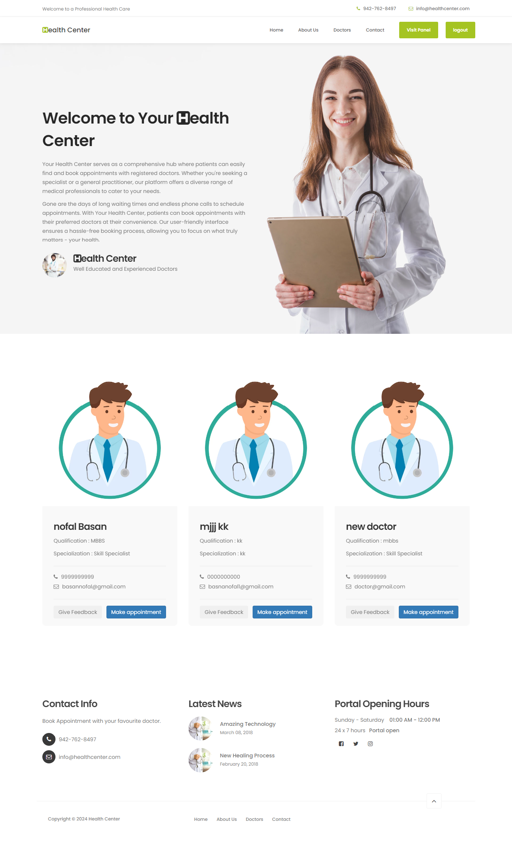

**Contact Us Page**

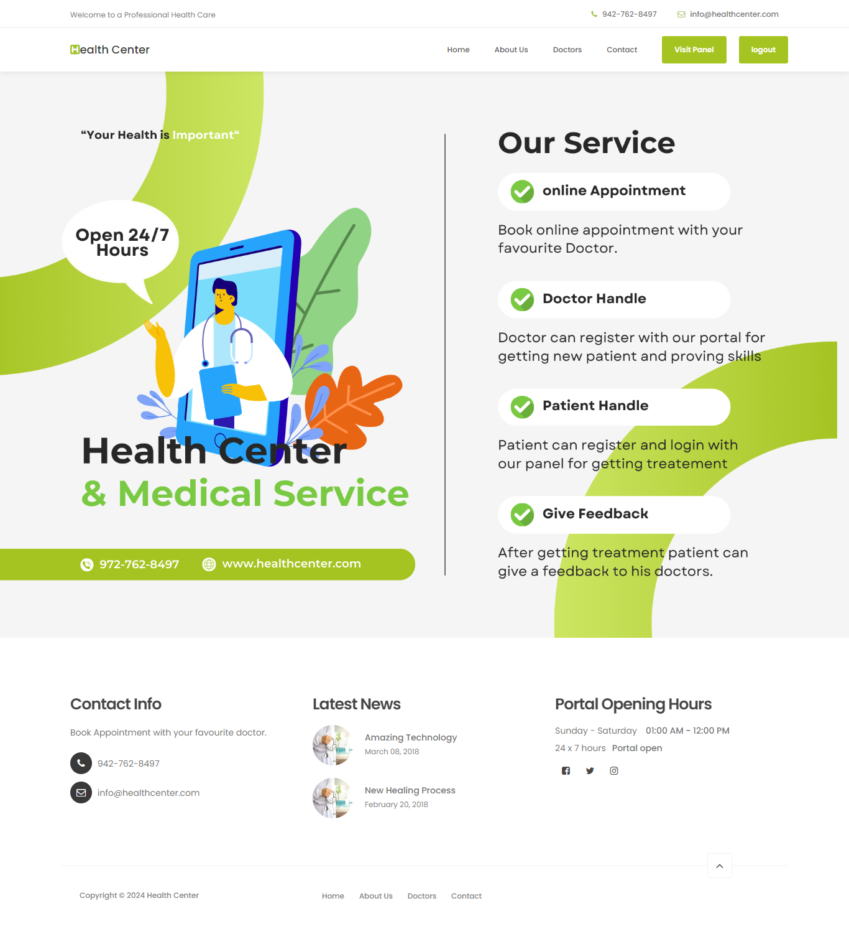

**Doctors Page**

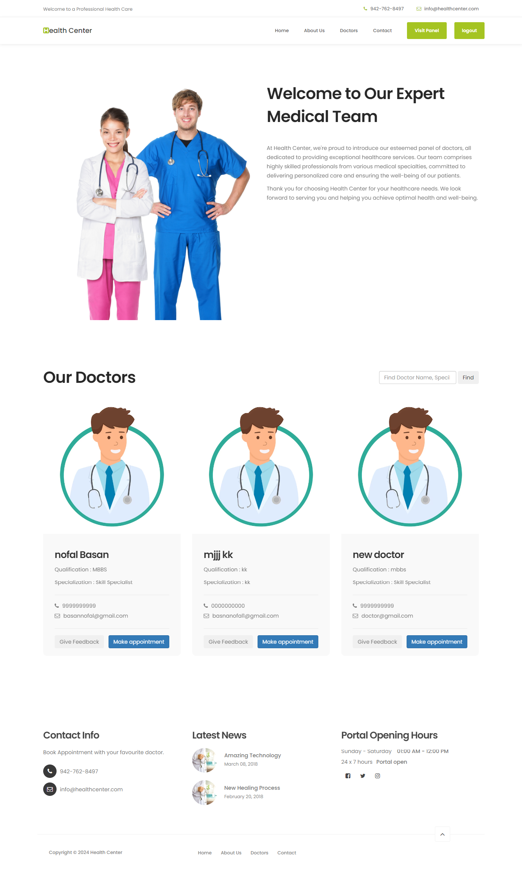

**Search Doctors**

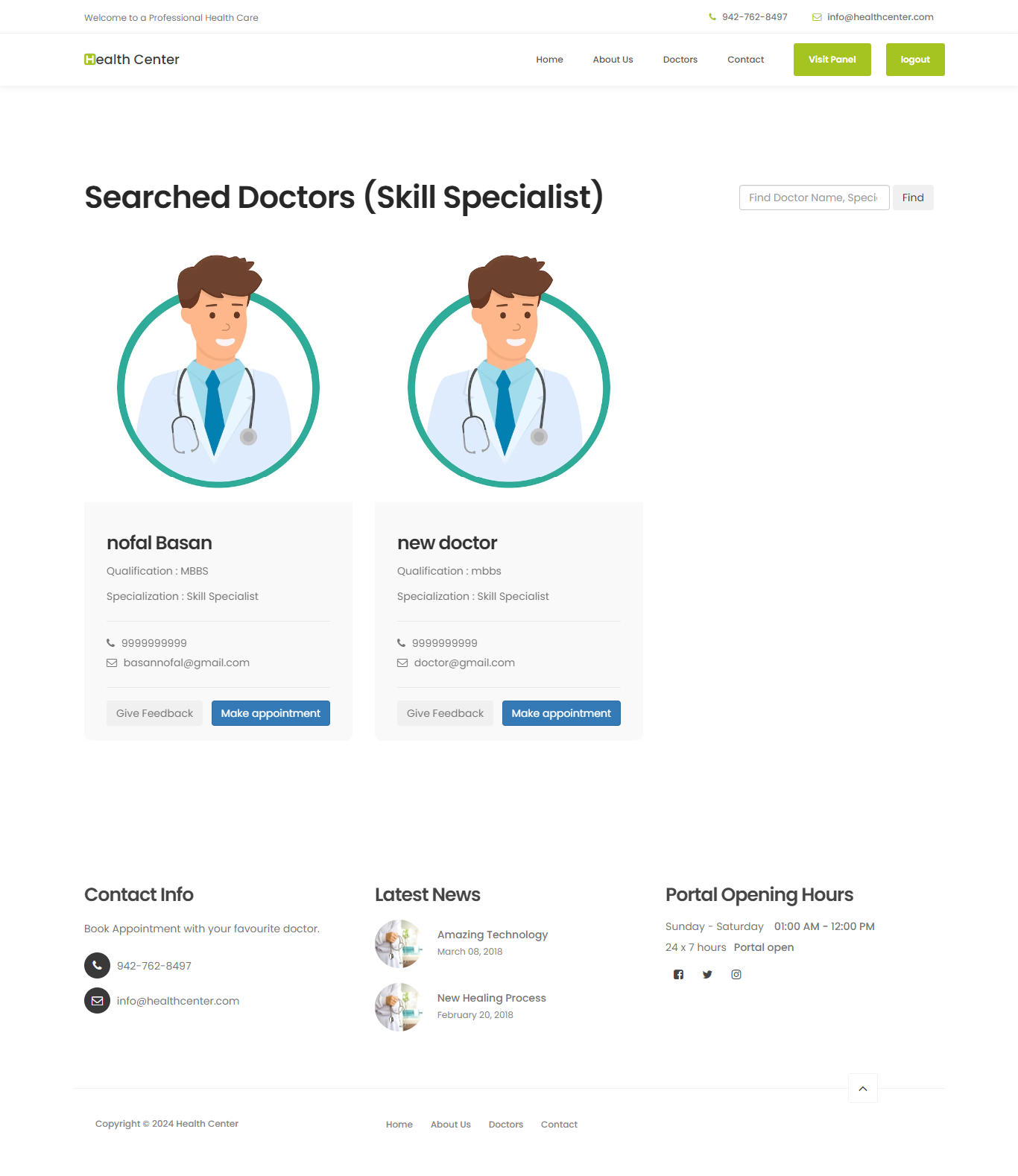

## Book Appointment

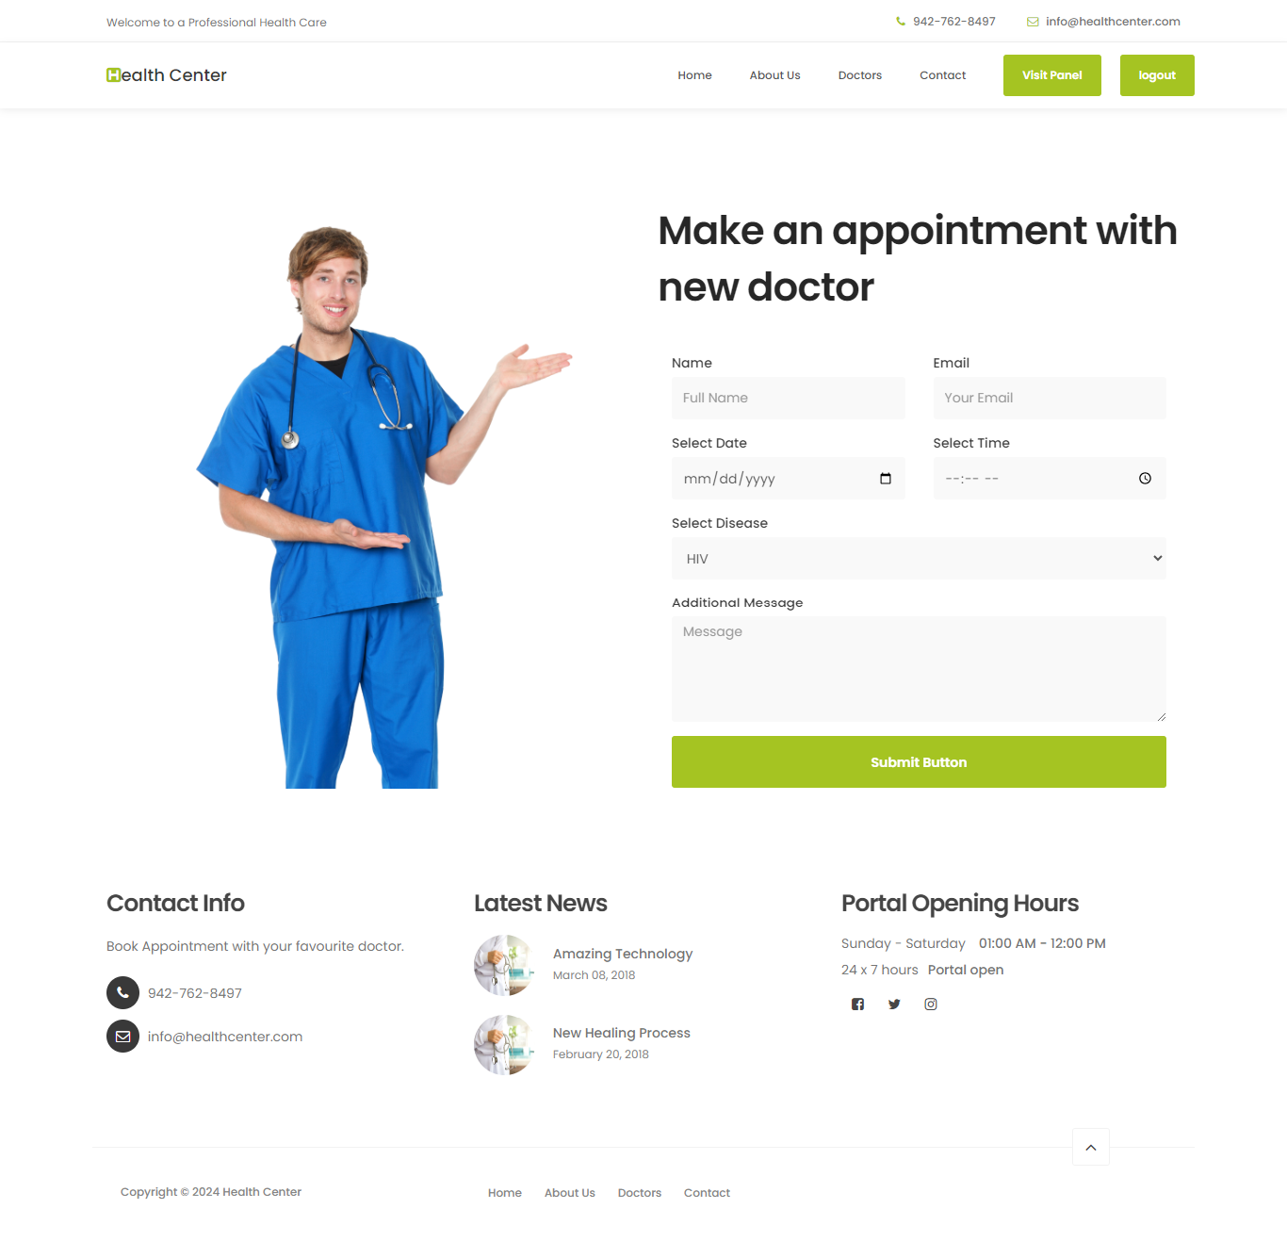

**Give a feedback**

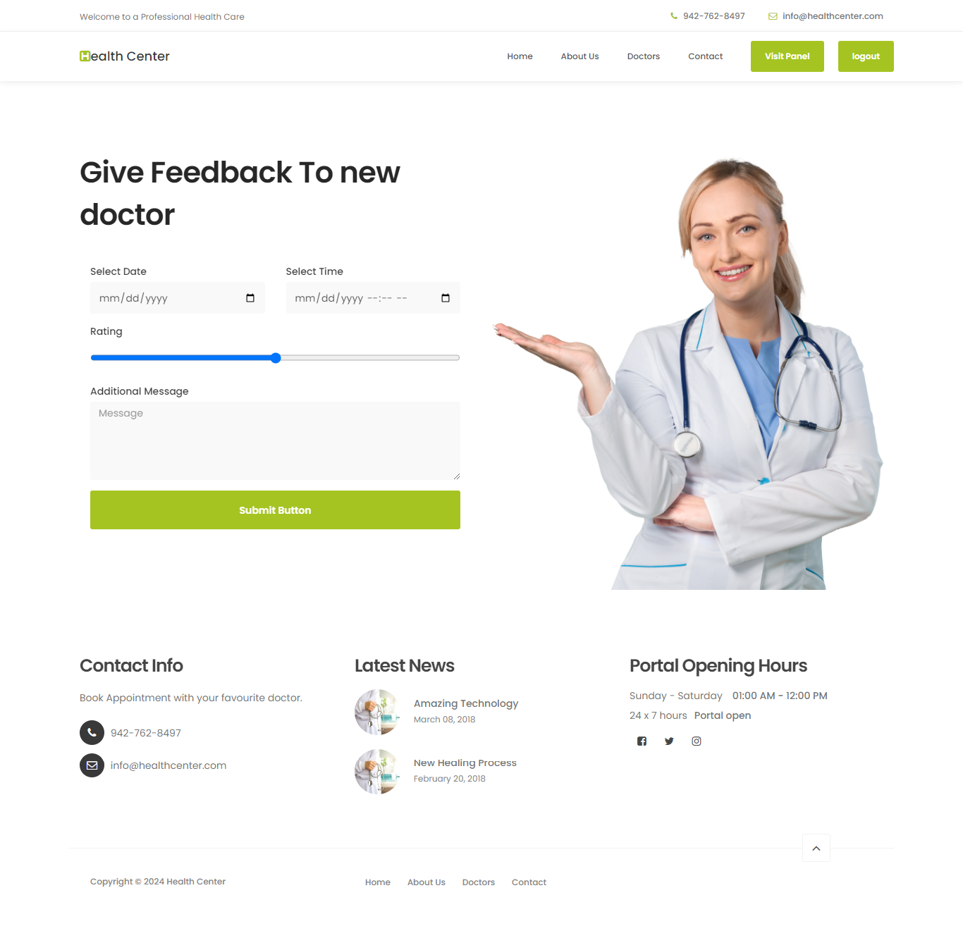

**Patient Appointments**

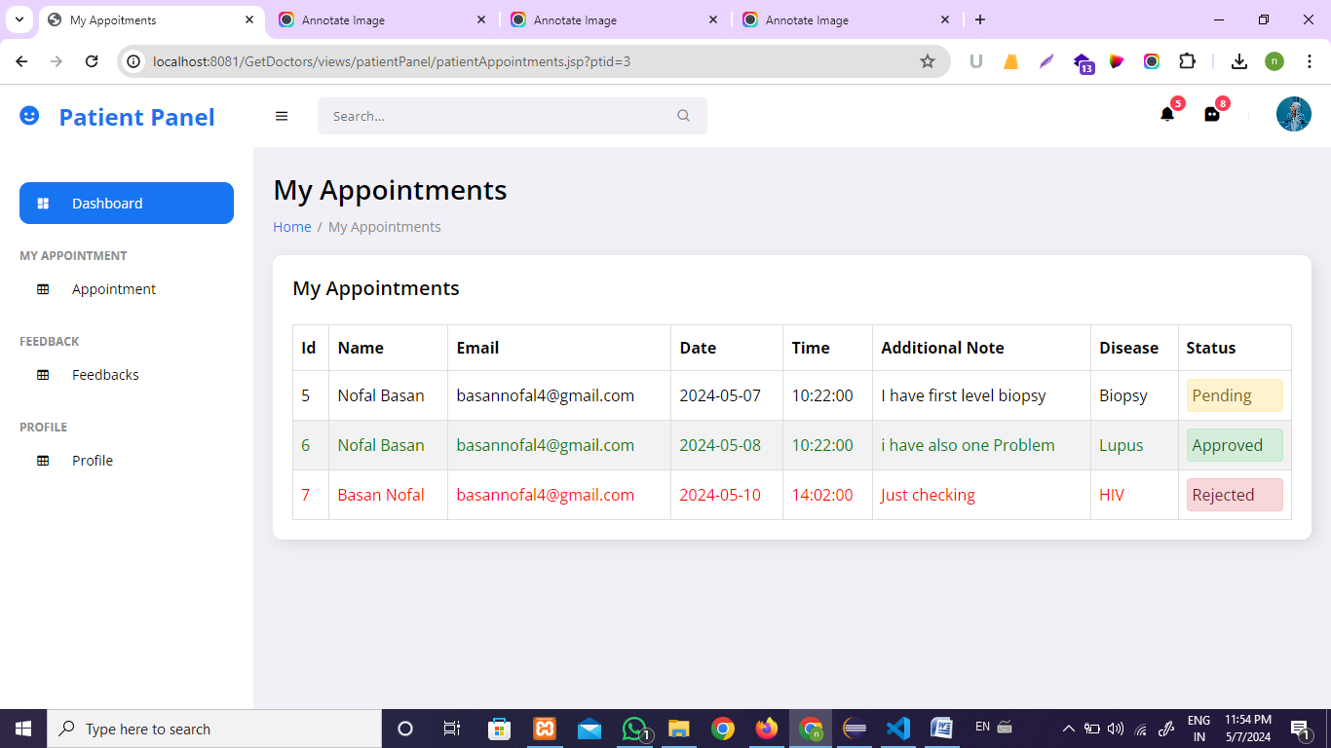

**Patient Feedbacks**

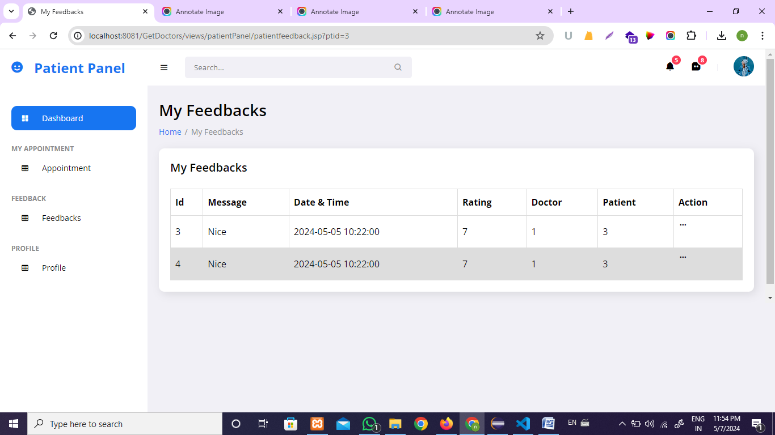

**Patient Profile**

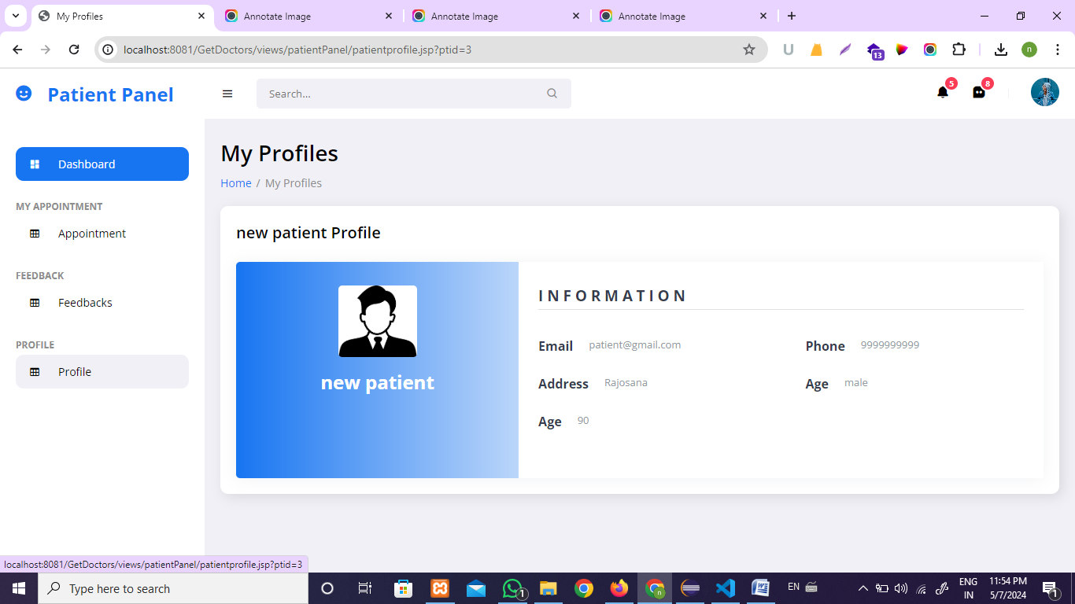

**Patient & Doctor Login Form ( switchable )**

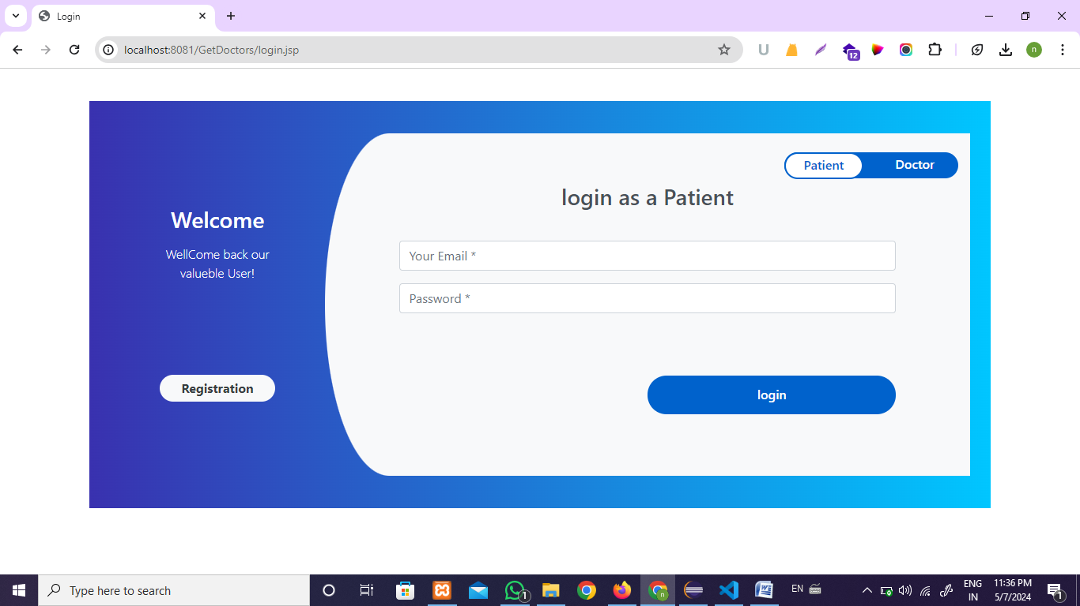

**Patient & Doctor Registration Form**

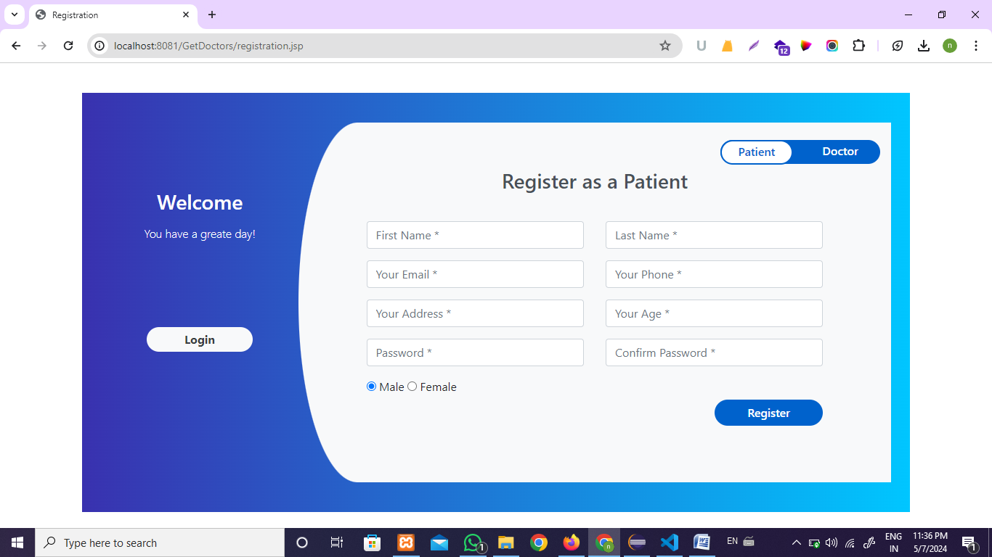

**4.1.2 Doctor Module**

**Doctor Appointments**

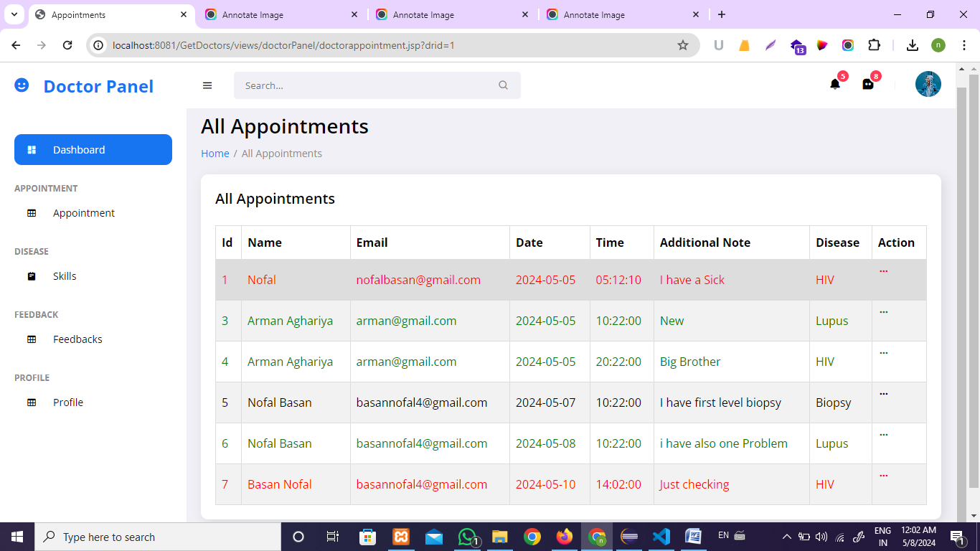

**Doctors Skills**

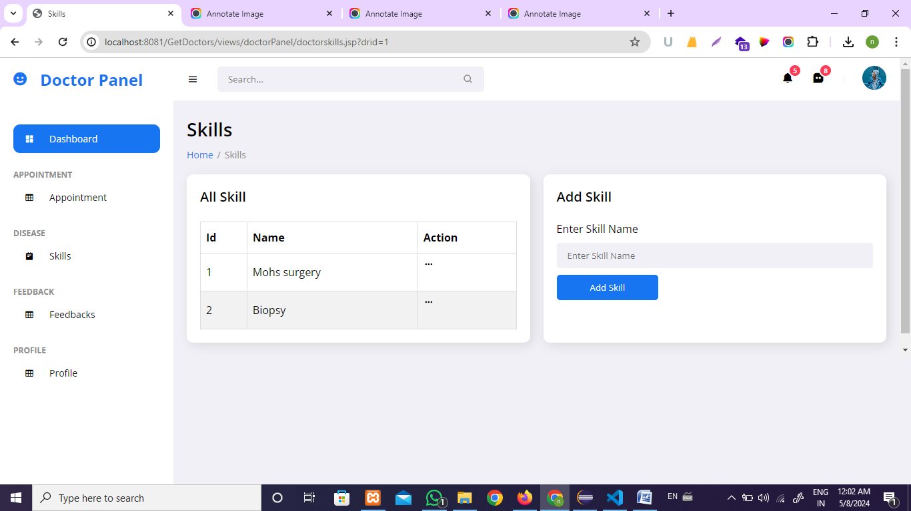

**Doctors Feedback**

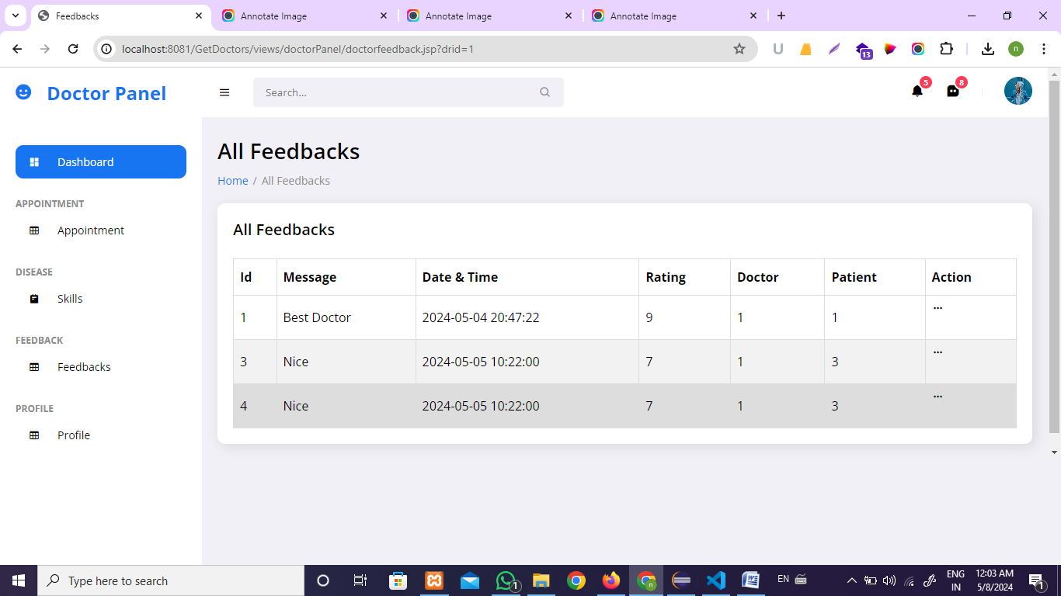

**Doctor Profile**

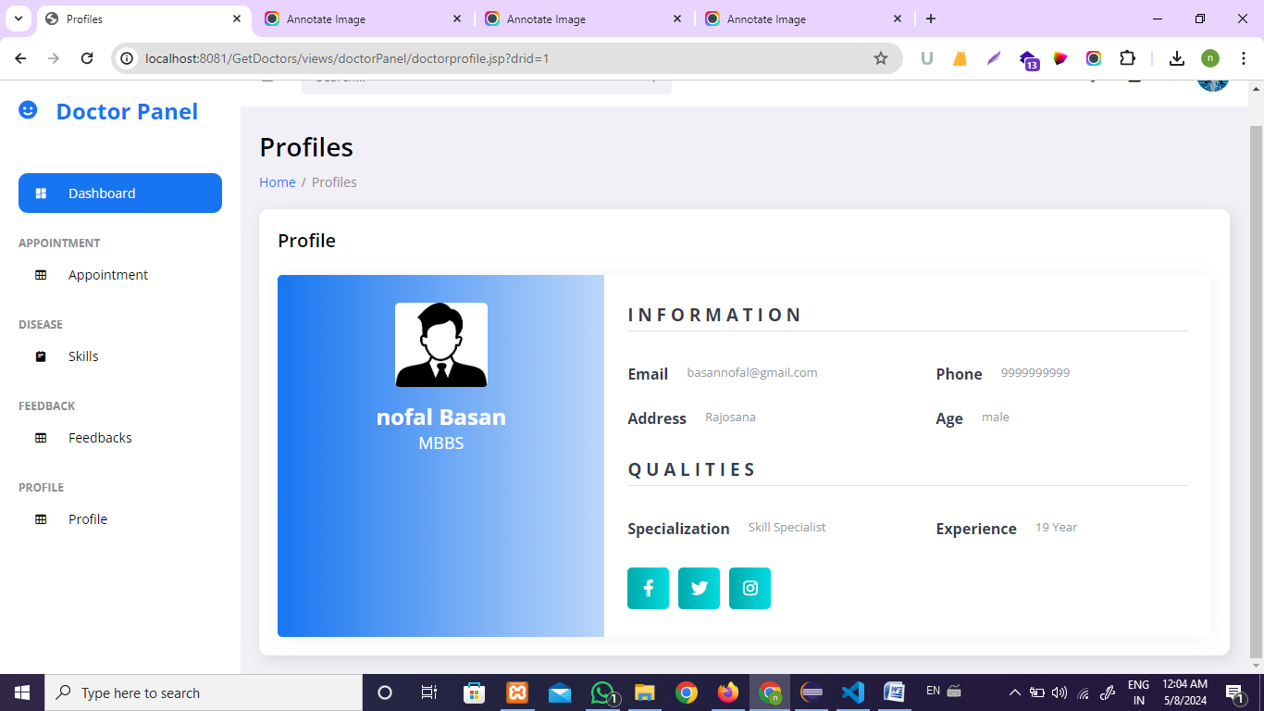

**4.1.3 Admin Module**

**Admin login Form**

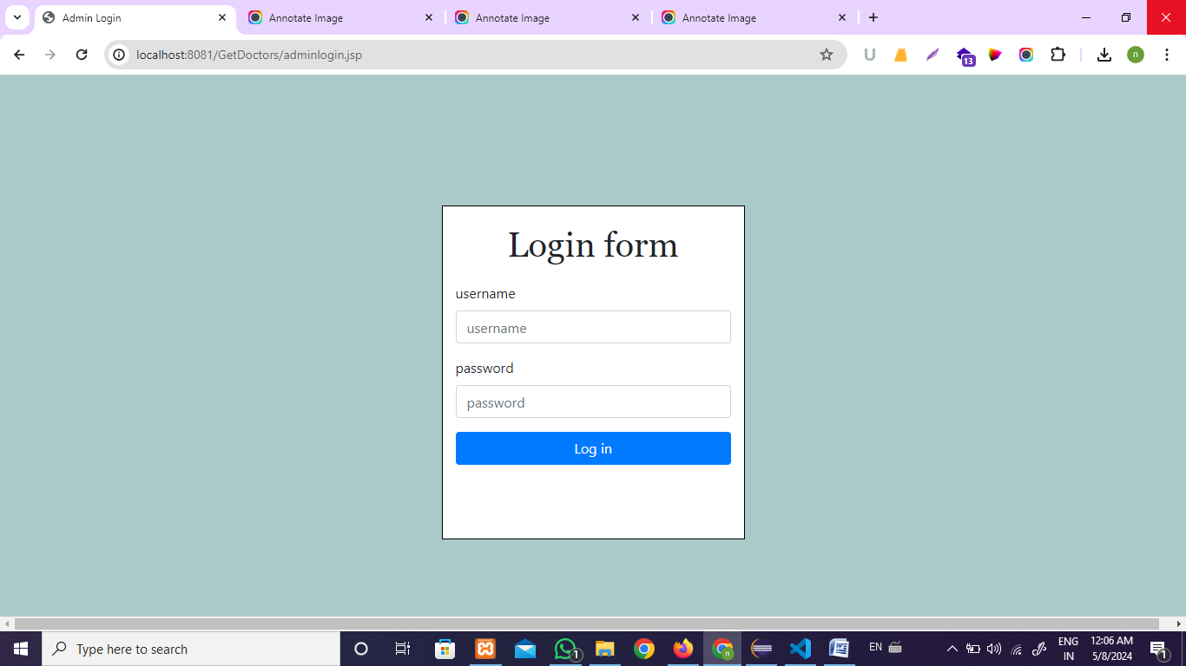

**All Doctors**

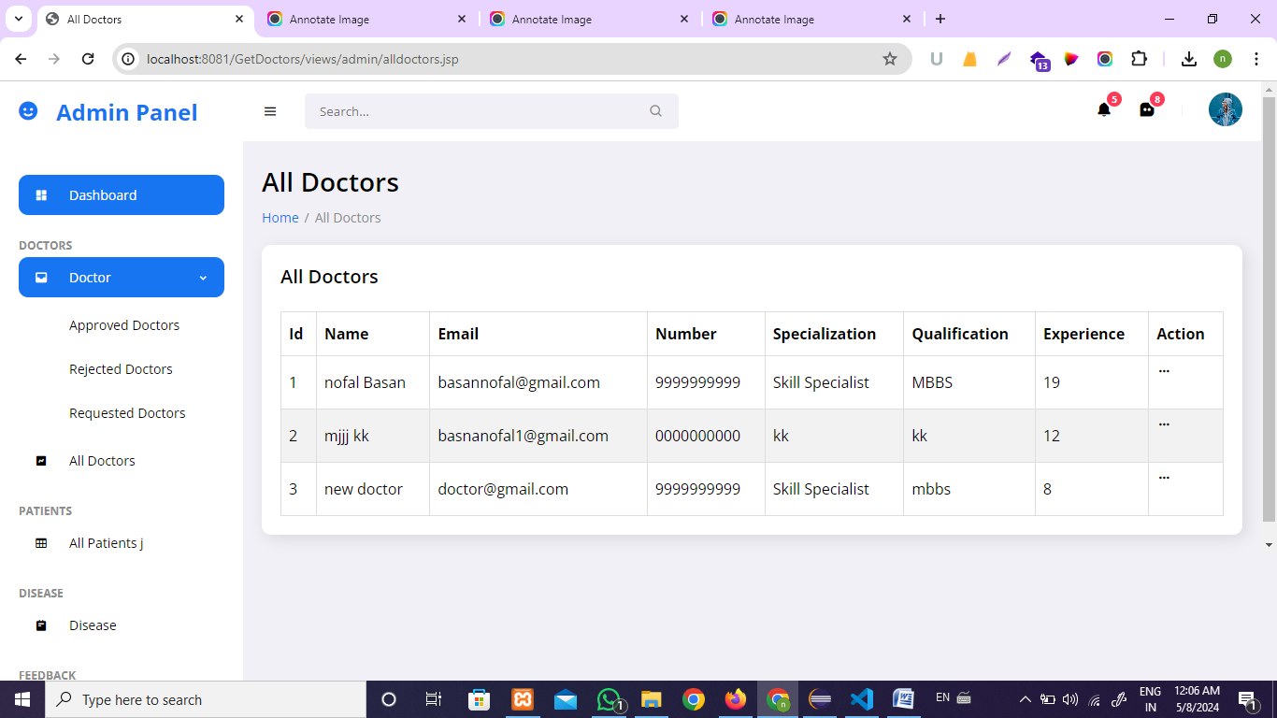

**Approved Doctors**

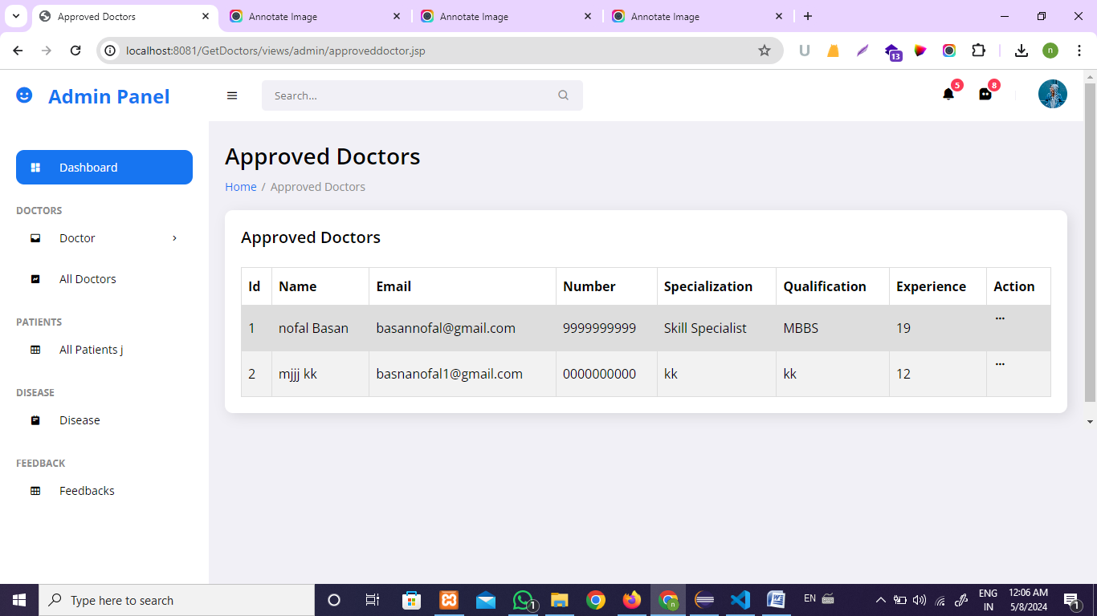

**Rejected Doctors**

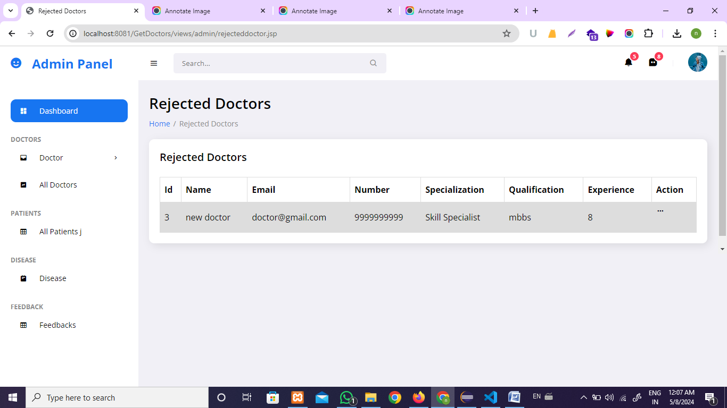

**Requested Doctors**

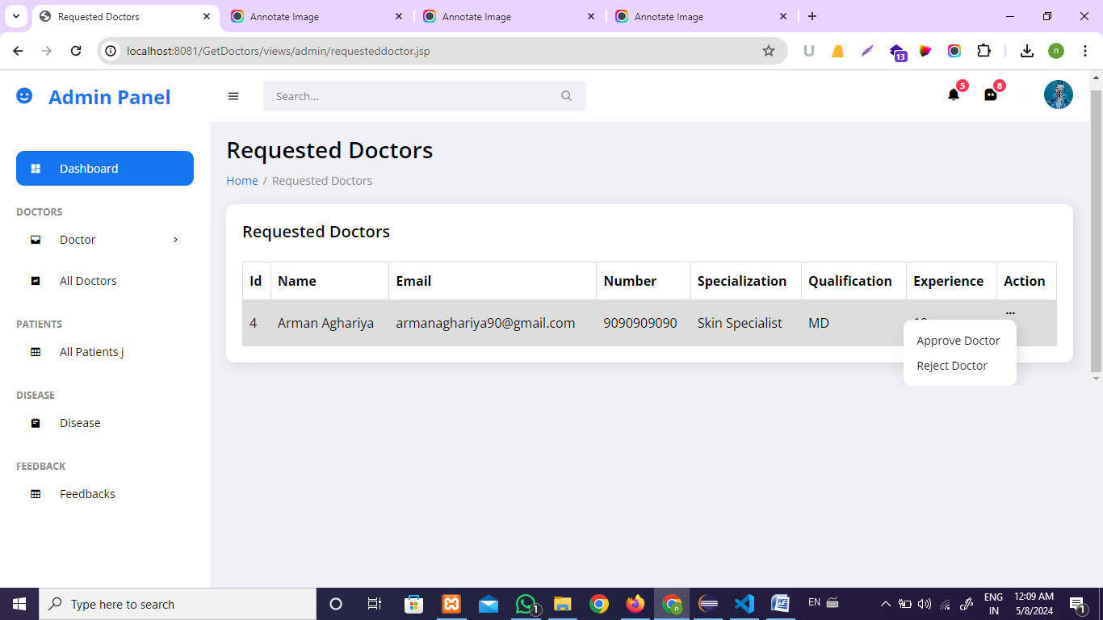

**All Patients**

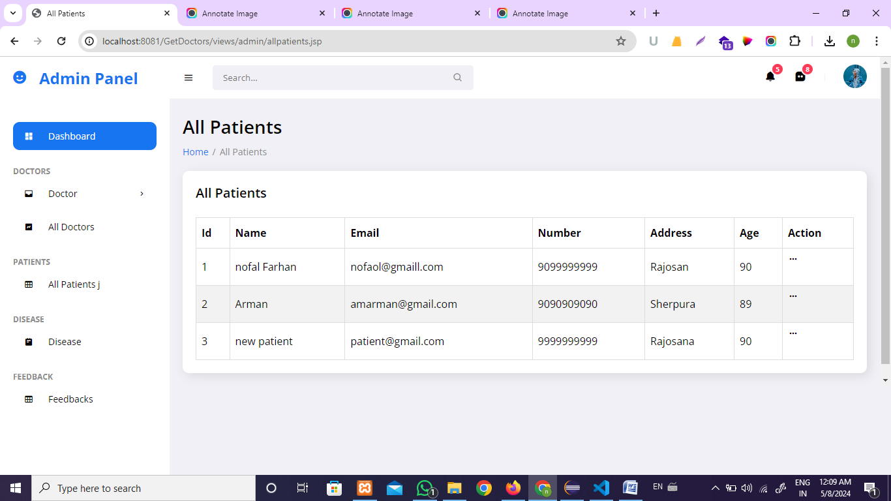

**Manage Disease**

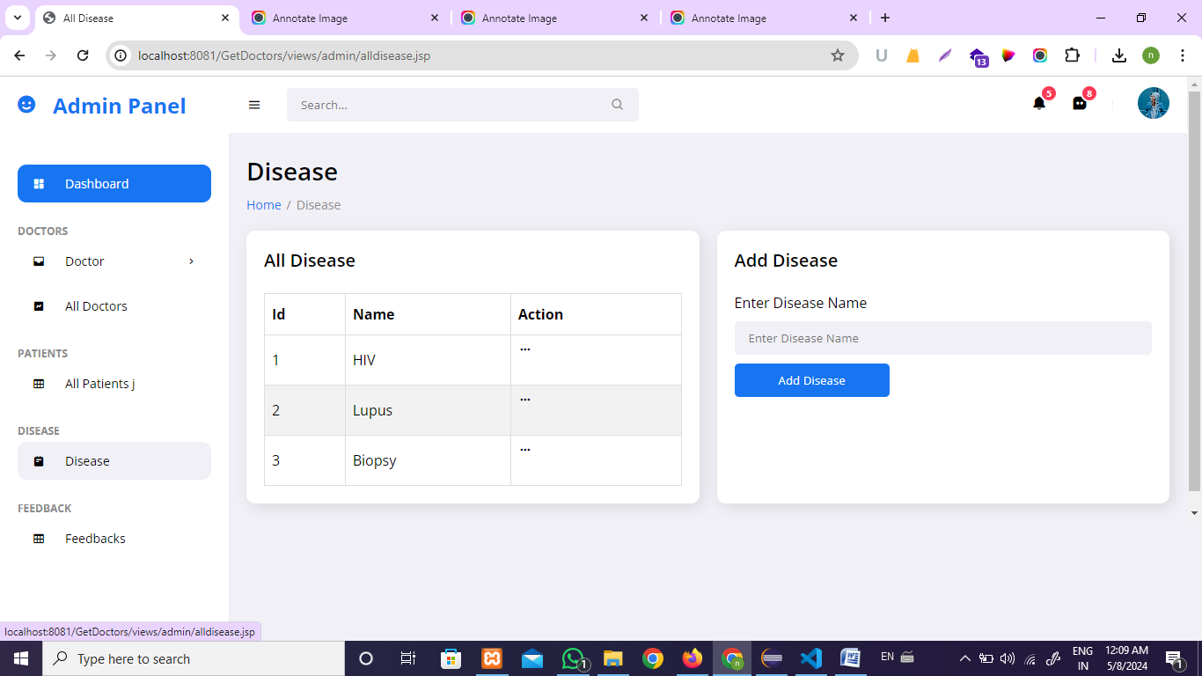

**Manage Feedbacks**

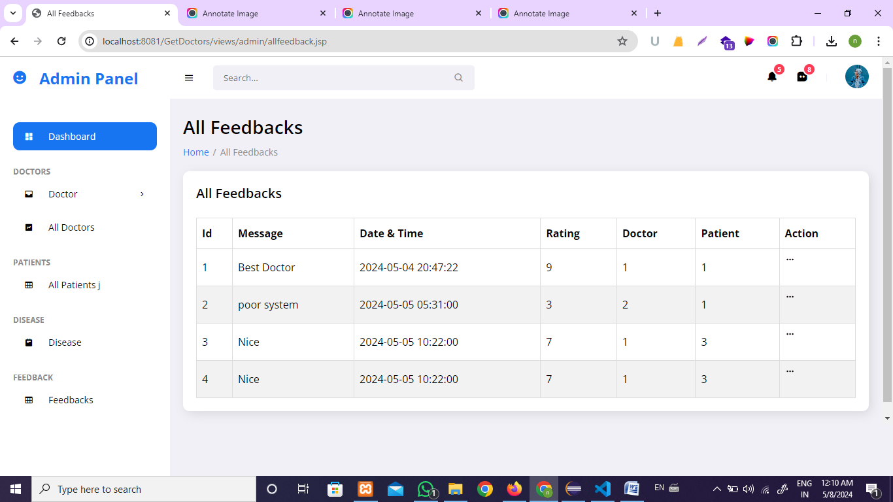

**5. Conclusion & Future work**

## Conclusion

* our project represents a significant step forward in revolutionizing the healthcare landscape by leveraging technology to enhance accessibility, streamline processes, and improve patient-provider interactions. Through features such as centralized appointment management, seamless communication channels, and transparent feedback mechanisms, we have successfully addressed key challenges in healthcare delivery.
* By empowering both patients and healthcare providers with tools for efficient scheduling, communication, and record-keeping, our platform has contributed to a more patient-centered and collaborative approach to healthcare. Furthermore, the integration of future enhancements, such as telemedicine, AI-driven decision support, and remote monitoring, promises to further elevate the quality and effectiveness of care delivery.
* As we continue to evolve and innovate, our commitment to advancing healthcare remains unwavering. We envision a future where access to high-quality healthcare is seamless, personalized, and inclusive for all. Together, we can shape a healthier tomorrow, where technology serves as a catalyst for positive change in the lives of individuals and communities worldwide

## Future Work

There is always room for improvement in any software package, however efficient it maybe. Butthe important thing is that the system should be flexible enough for future modifications. This system has been designed in such a way that the modifications can always beincorporated without affecting the other modules, as the modules have been keptindependent of each other.

* Provide the facility for SMS Integration.
* Provide Health Card generation for the patients
* Provide downloading facility of other software.

**6. References & Bibliography**

World Wide Web:

[**www.w3schools.com/**](https://www.w3schools.com/)

[**www.mysql.com**](http://www.mysql.com)

[**www.javatpoint.com**](https://www.javatpoint.com/)

[**https://chatgpt.com/**](https://chatgpt.com/)

[**www.canva.com**](https://www.canva.com)